1. Heroku URL : <https://tranquil-ravine-60150.herokuapp.com/news/>
2. Features to implemented:
3. Functional login/logout buttons
4. Account view so authors can see their profile information.
5. Create Account functionality, so a new user can sign up to be an author.
6. View stories by a particular author.
7. Show/Hide the relevant information and buttons based on whether the user is logged in/out (e.g. should only be able to see the button to create a new story if I am logged in)
8. Enable/Disable the relevant features based on whether the user is logged in/out (e.g. should only be able to create a new story if I am logged in).

Additional Features

Add the ability to update and delete stories.

1. Github link : <https://github.com/SheCodesAus/she-codes-django-news-project-neets1981>

Home page

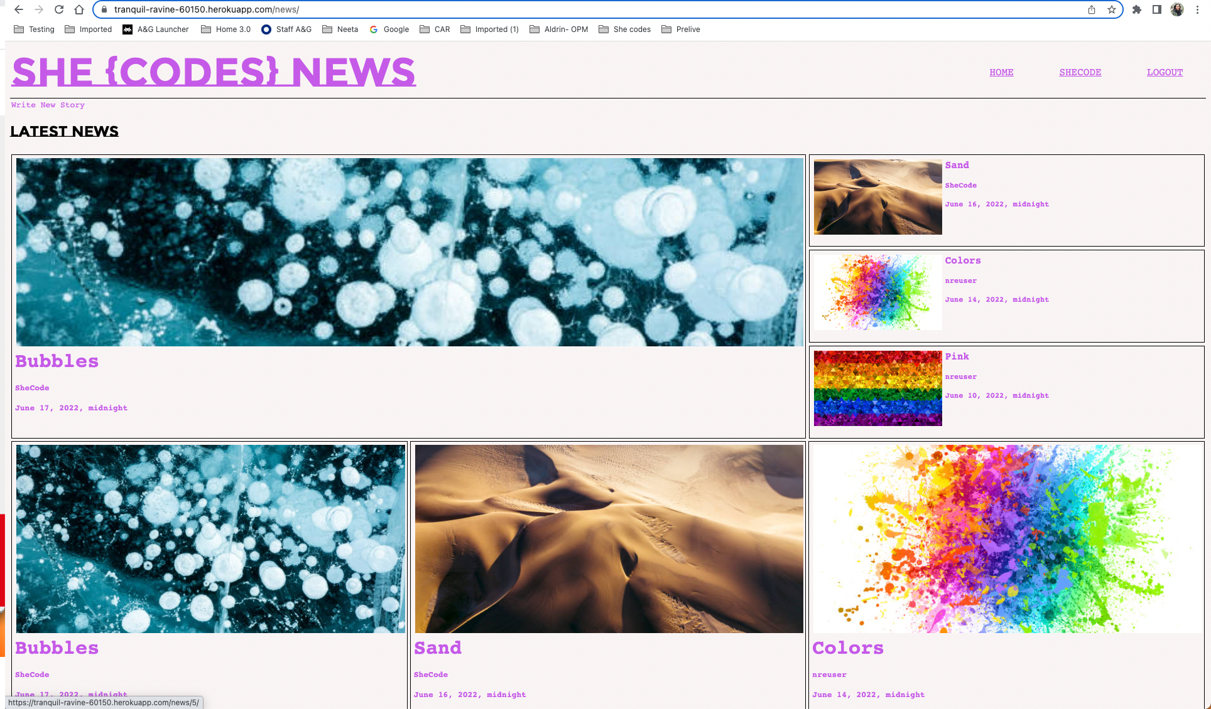

Update and delete stories

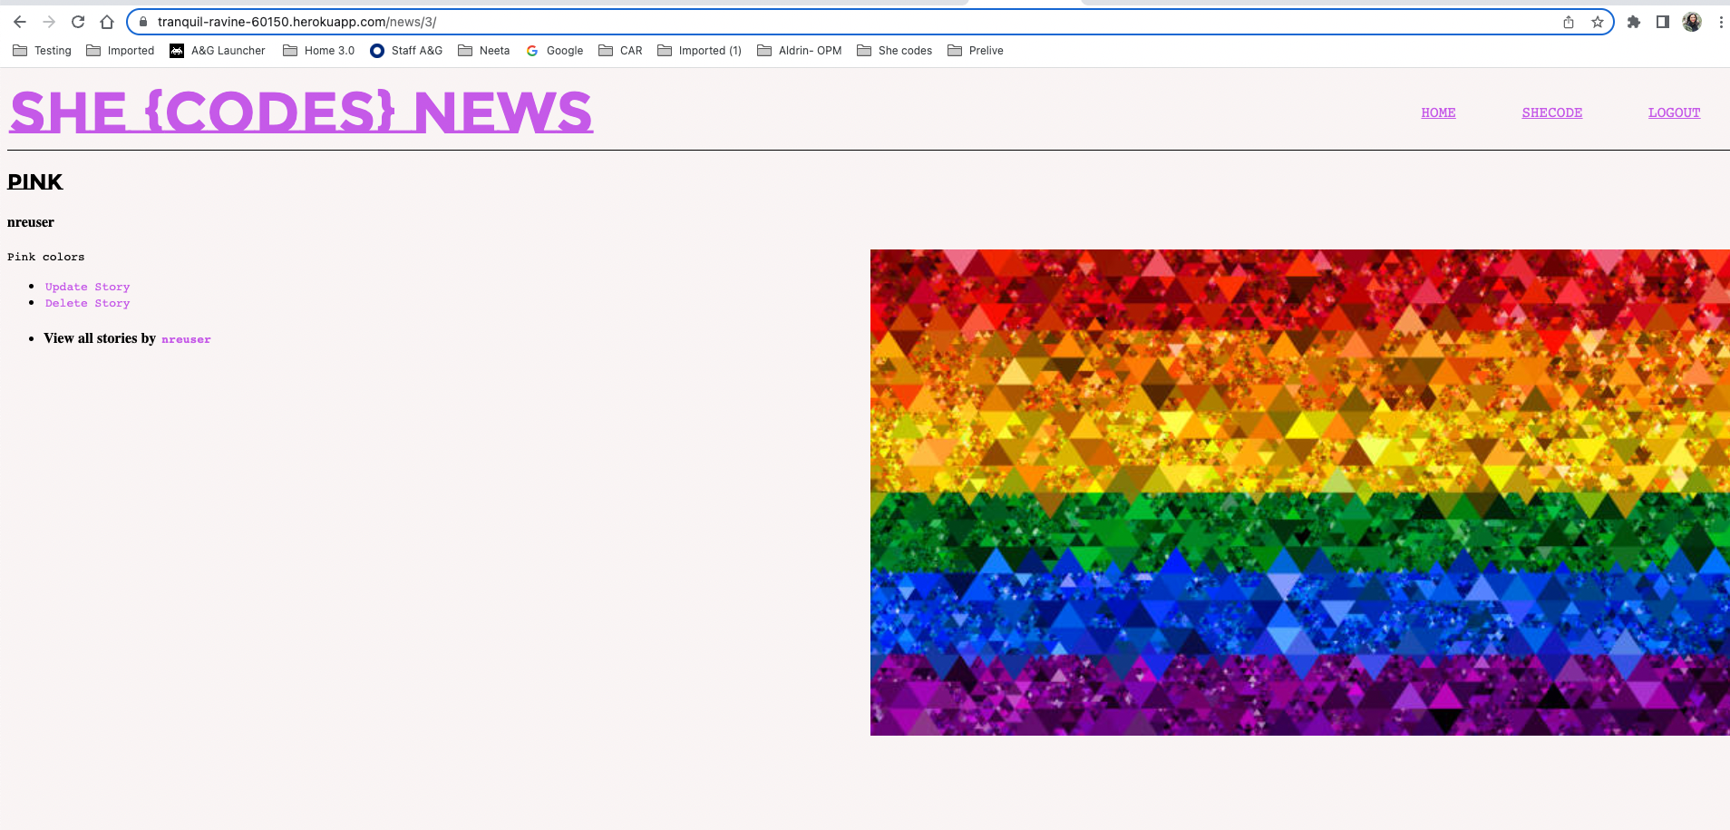

Profile info

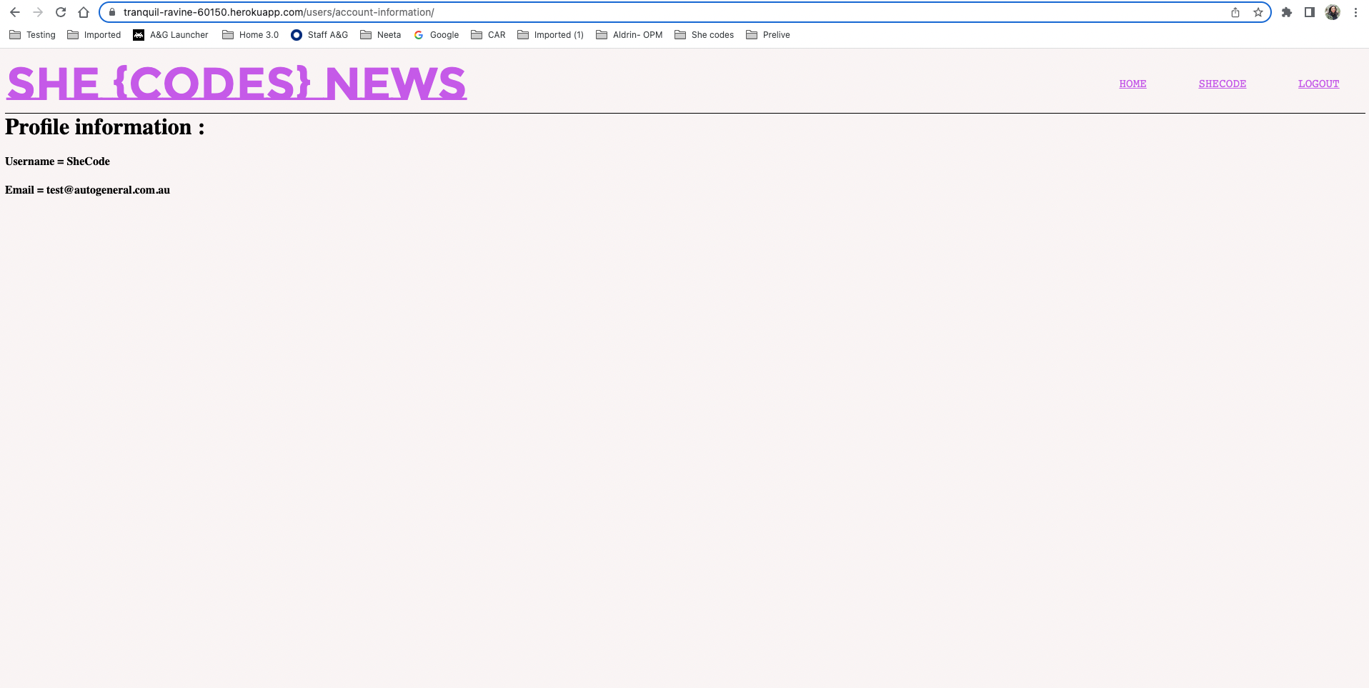

View stories by Author

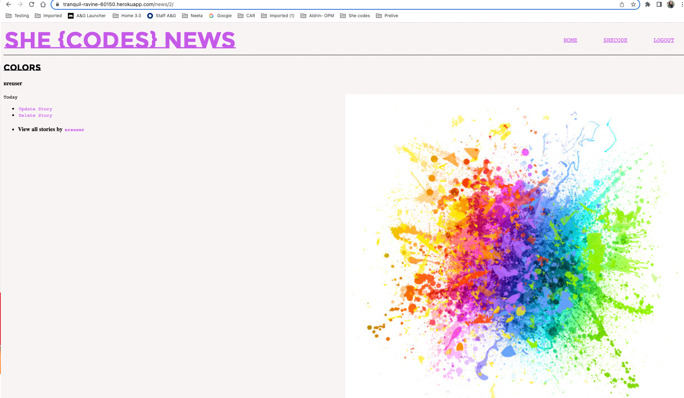

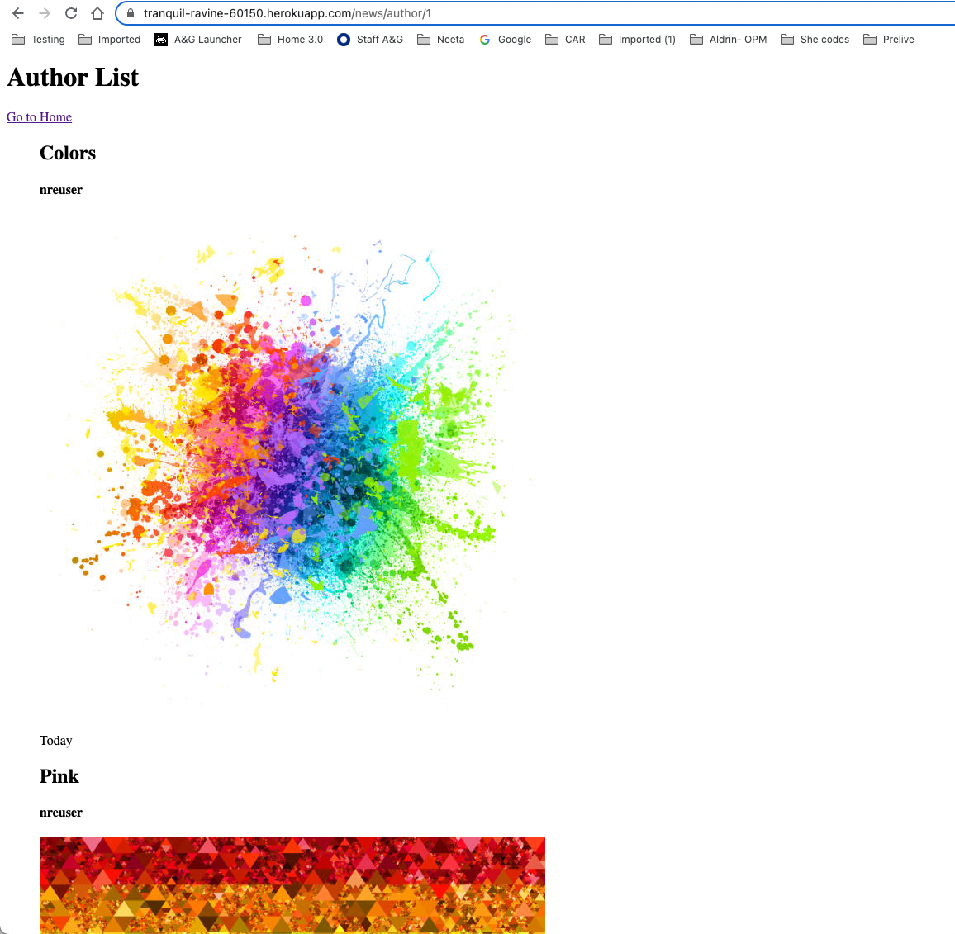

Show / hide button based on login and logout

